Module 1: Hands on Project - Building Virtual Machines
Type 2 Hypervisor: Oracle Virtualbox
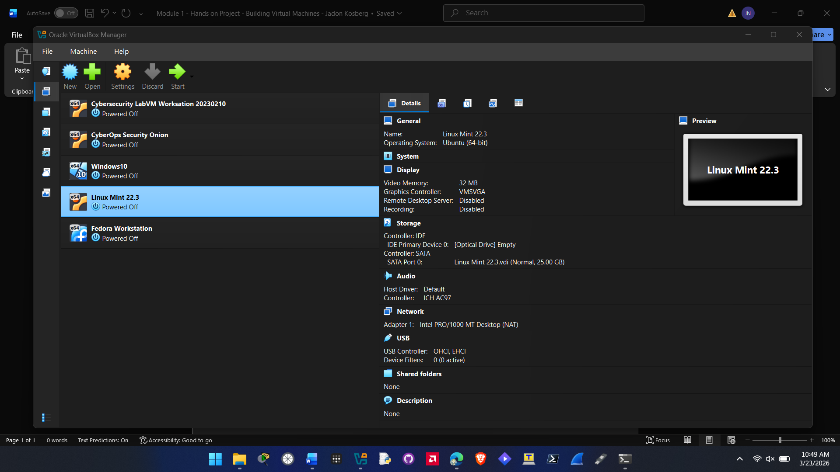

Linux Mint Installed
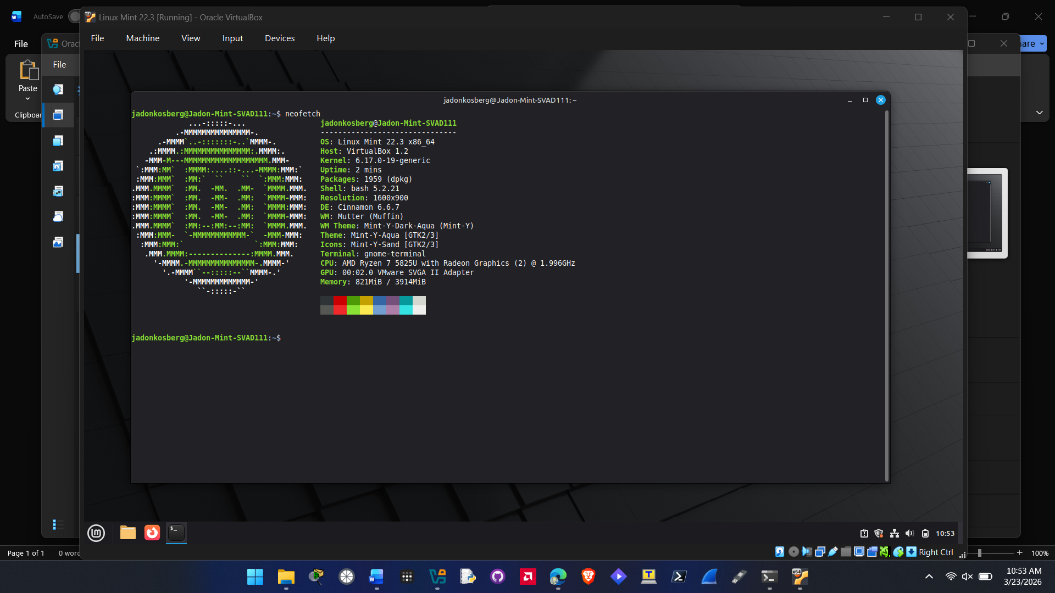
Fedora Workstation Installed
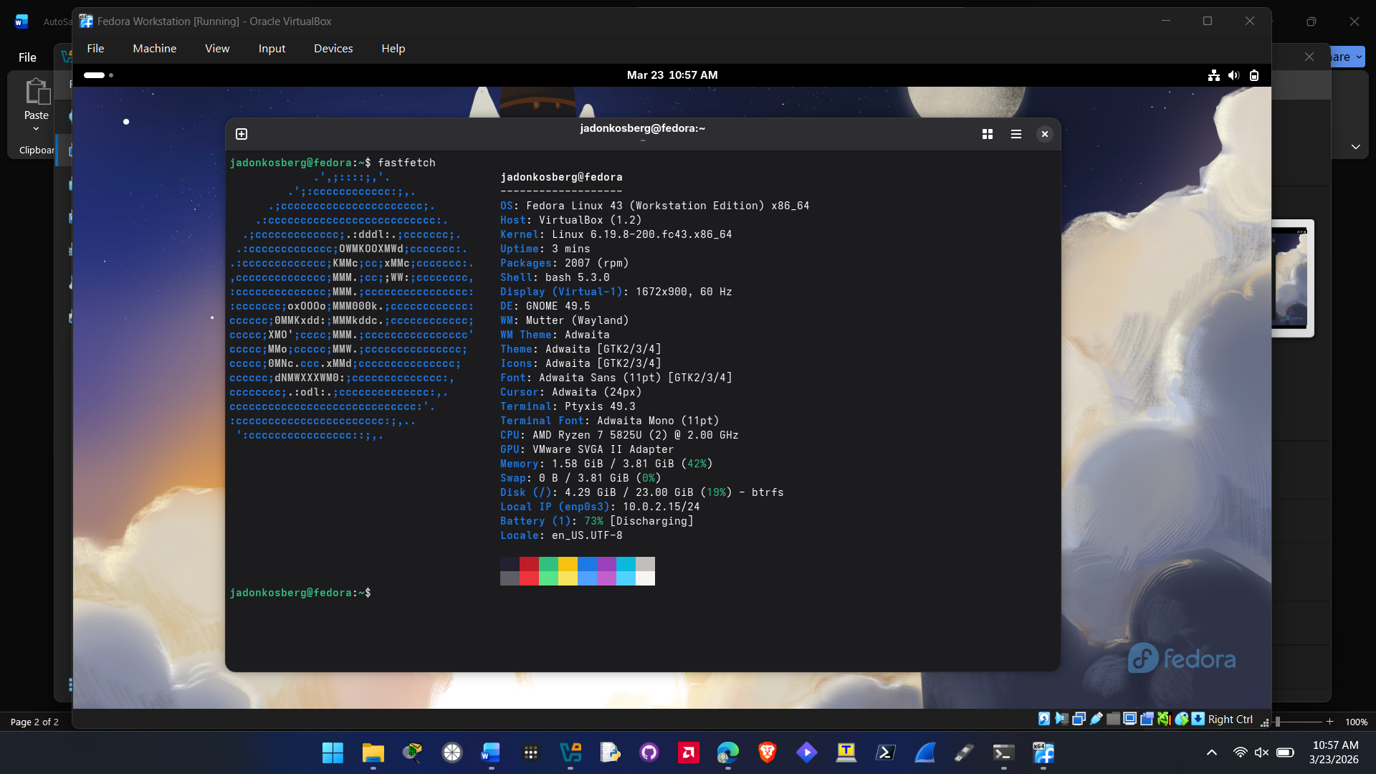

- List of any troubleshooting, resolutions, and third-party references used for troubleshooting

I did not have any difficulties installing the two VMs the only minor thing I had to do with Fedora was manually eject the installation ISO as it kept booting into it.

I used these two guides to help me:
https://itsfoss.com/install-linux-mint-in-virtualbox/
https://itsfoss.com/install-fedora-in-virtualbox/

